In Of Mice and Men, Curley's wife thinks she could have "went with shows" (Steinbeck 78), but instead performs for all the men on the ranch. In her introduction, she is described as "heavily made up" (31). Much has been written about this mysterious character who consistently performs any role other than herself. She exists by playing, alternately; wife, temptress, sex object, and dreamer.
Of Mice and Men was written in 1936, and was adapted to be performed as a play in 1937. Claire Luce, the actress hired to play Curly’s Wife, wanted more information on the character. John Steinbeck wrote the following letter to her.
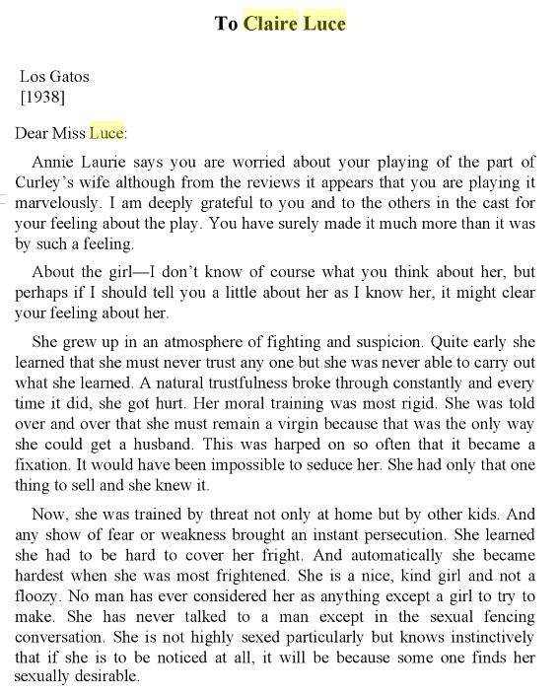

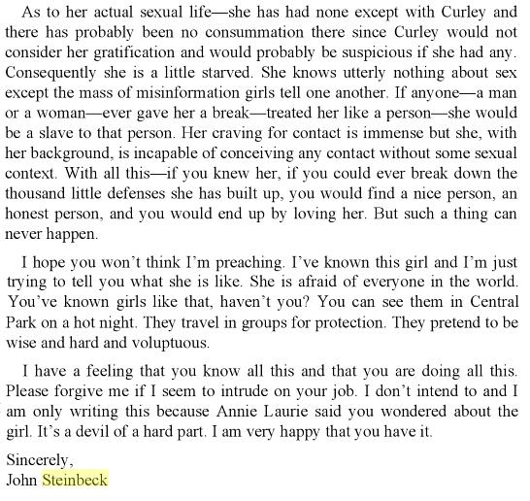

X

X

- John Steinbeck, the author of Of Mice and Men, uncovers new information about the character of Curly’s Wife. What is it?

- If the men on the ranch knew this information of her upbringing, in what way should they treat Curley’s Wife differently, or how should they treat her?

- What should John Steinbeck incorporate from this letter into Of Mice and Men to make the character of Curley’s Wife better understood?

