Name: ________________________________ Period: _______ Date: _____________
Published October 14th, 2010
By Darren Franich

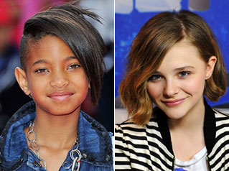
So far, most early Hunger Games casting predictions have focused on Katniss Everdeen (see the Great Kaya/Lyndsy Debate) and the boys who love her. But what about Rue? The youngest tribute (12 years old) in the 74th Hunger Games, Rue would be a difficult role for any pre-teen actress. Adding some complexity: the fact that Rue is clearly described as having “satiny brown skin” on page 98. Don’t worry if you didn’t know that Rue and her fellow District 11 tribute Thresh were black. I didn’t either after my first read. (Like most people, I raced through the book in about three seconds.) But now that it’s time to cast the movie, we should ask: How important is it that Rue be played by an African American actress?
Image Credit: Gareth Cattermole/Getty Images; Michael Kovac/Wire Record 20862974
You could argue that, in Panem, race matters much less than which district you’re from. It wouldn’t radically alter the structure of THG if Rue were played by, say, Chloe Moretz. But it feels like there should be some color in this movie, if only to avoid something like the color-bleached Last Airbender or the caucasiafied Earthsea. And there’s arguably a deeper level of meaning to Rue’s ethnicity: one commenter on Keith Staskiewicz’s recent post argued that District 11, where citizens work all day in the fields and live in fear of the Peacekeepers, explicitly references plantation life in antebellum South.
What do you think, Shelf Lifers? Would you be offended if they didn’t cast a black actress for Rue? Doesn’t bigscreen sci-fi/fantasy just need more non-white actors on principle? Do you agree with our choice of Willow Smith for the part, or have the fates decreed that Chloe Moretz absolutely must have a role in this franchise?

