Name:____________________ Period:___________ Date:____________________

California's important Velcro crop, vital to the clothing, footwear, and sporting goods industries, has been severely stressed by drought, disease, and pests.

Background
Velcro, an engineered crop, consists of two distinct strains: hooks and loops. As any user of Velcro knows, a strip of hooks clings to a strip of loops as the springy hook-shaped fibers latch through tiny but firm loops. Gentle pressure allows the hook strip to be pulled from the loop strip. The user may repeat the process time and again, making this product a convenient, versatile replacement for zippers, buttons, snaps, laces, and other forms of fastener in wide-ranging applications.
California's climate and soil conditions make the state an ideal venue for and successful producer of both strains of Velcro. For obvious reasons, of course, the hook strain must be grown in fields separated from those with the loop strain. This is often accommodated by widely spacing separate fields of the two strains among large expanses of cotton, alfalfa, or other crops.
For competitive and industrial confidentiality reasons, of course, the crop is not widely highlighted in crop reports. A little Velcro goes a long way, as both strains are densely packed on their respective mature plants, and the entire crop is dwarfed by other field crops, most notably cotton. Nonetheless, the crop is of high value and can be a substantial profit builder for the successful grower.

The Issues
Three issues have conspired to threaten and diminish the crop in California's southern San Joaquin Valley, especially drought-affected Kern County.
- Dry and windy conditions have caused hook and loop spores to commingle even across widely spaced fields, resulting in tangled Velcro bolls combining both strains and unprocessable by any known means.
- Invasions of disease and pests have damaged the crop. Specifically (1) the flaccidity virus has resulted in weakened hooks, unable to hold adequately or even to snap through the corresponding loops, and (2) the pest millipedus minisculus, or 'tiny thousand-footed creature', has multiplied in the Velcro fields, frequently becoming so ensnared in the developing loops as to make the crop unharvestable.
- Drought has both limited water for the westside Velcro fields and exacerbated crop-stunting salinity.
Crop management for Velcro is made especially difficult by the need to outfit field workers head-to-toe in Teflon jumpsuits. (The Teflon crop is another issue, to be tackled in a future report in this series.) Absent such protection, field workers are in danger of becoming enmeshed in the Velcro bolls while working the fields. Clothing and even body hair may become entangled with the hooks or loops, requiring difficult extraction procedures. The Teflon jumpsuits in turn require personal cooling equipment and expensive maintenance. When available, it is preferable to hire a crew composed entirely of professional body builders, who are both strong and hairless from head to toe.
All in all, cultivation is a demanding and costly process, making profit margins unusually vulnerable to price swings and crop productivity losses.

Status
As the chart and table below so starkly show, the combined assaults on the Velcro crop have had marked effects.
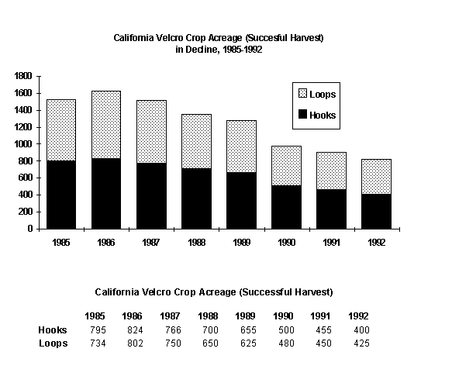

Recommendations
In view of the singular nature of this specialized crop and its high contribution, when successful, to the financial well-being of the farmers who have the tenacity to grow it: The respective agricultural commissioners and extension personnel should emphasize proper spacing requirements for fields of the hook and loop strains. Research, training, and inspection are all necessary. Responsible officials should redouble efforts to eradicate flaccidity virus and millipedus minisculus. Water officials should accommodate the special needs of this high value crop in determining allocations, especially in years of water shortage. By these means, it should be possible to restore the vigor, productivity, and profitability of this specialized but significant crop.

Postscript (December 1996). The return of relatively normal rainfall patterns, together with sunspot conditions that have decimated flaccidity virus and millipedus minisculus, have contributed to a strengthened Velcro crop, but no one knows what the future might bring. Consider investing in zippers and buttons.

